##### WINMAX

##### EtherCAT configuraton Management

##### Design (CQ 18276) Document

##### May 2, 2013

##### Rev 2

# Introduction

This document proposes a design for managing the configuration files associated with the new WinMax EtherCAT digital drive system, internally known as BBQ. The configuration parameters are significantly different between the analog and digital servo drive systems, which provide an opportunity to change how the system stores its configuration data. Also, the digital drive system does not need to maintain backwards compatibility with the analog drive system as the BBQ software can’t be used to upgrade an existing machine without extensive hardware changes.

The configuration files used with the analog drive system consisted of 18 separate files (WSysFix.sys, WSysInt.sys, WSpindle.sys, WSoftCfg.sys, WSofttune.sys, WMCode.sys, WRotHead.sys, WStandard.sys, WProbe.sys, WIntCfg.sys, WAtcMap.sys, WWarmUp.sys, Canbus.cfg, WMachineComp.sys WLeadScr.sys, ABASCII.txt, Ladders.txt and Ladders_Desktop_RT.txt). Instead of using multiple configuration files, the digital drive system will use a single database file that will contain all configuration data for a specific machine.

The electronic copy of this document is located in the Sharepoint, Developers Corner, RT folder and is called Ecat Configuration Management Design (CQ 18276).docx.

# Analog Drive System Configuration Management

The configuration files for each machine are stored in TFS in the tree structure shown in Figure 1. The machines are located under the MCD (Machine Configuration Directory) folder and are divided into three main categories, Engineering Machines, Field, and Production. Those folders are further subdivided into groups (Other, Specialty machines, VM Series, etc) and into machines (VM10 40T SL, VM10HS 30T SL, VM10P 30T SL, etc). Machines are subdivided into Config, MCD and Misc folders. The Config folder contains the WSysFix.sys, WSysInt.sys, WSpindle.sys, WSoftCfg.sys, WSofttune.sys, WMCode.sys, WRotHead.sys, WStandard.sys and WProbe.sys configuration files. The MCD folder contains the WIntCfg.sys and WAtcMap.sys files. The Misc folder contains the Canbus.cfg file. The WMachineComp.sys and WLeadScr.sys configuration files are not stored in TFS because they are machine specific and are created separately.

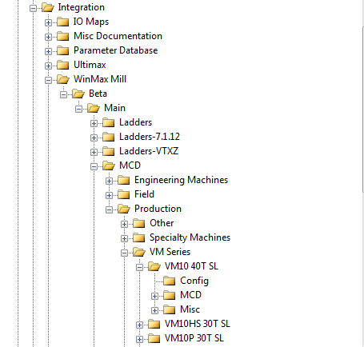

Figure 1 – TFS Integration Main Tree Structure

Another TFS folder used in the configuration file management is the WinPC32_Config folder as shown in Figure 2. The WinPC32_Config folder is further divided into machines (VMX30U, Console, DCX, DCX22_SL, etc) and the machine folders contain the ABASCII.txt, Ladders.txt, and Ladders_Desktop_RT.txt files. The machine folders also contain 2 specific WinPC32 project files named for their machine (example: BX30U.prj and BX30U.txt). These 2 files are not used by the WinMax app; they are only used with the WinPC32 development tool and are located in the machine folders as a convenience for the WinPC32 developers.

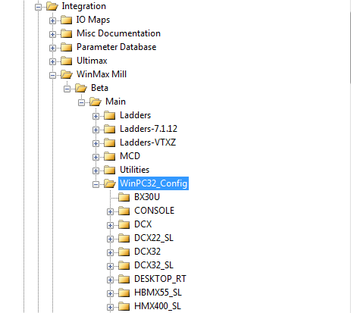

Figure 2 – TFS Integration WinPC32 Config Tree Structure

Using the Machine Selector app, the user selects a specific machine and the app copies the appropriate configuration files from their source locations (TFS or Install folder) to their destination locations used by the WinMax app. The destination locations include various subfolders under the R:\Hurco\Winmax\ConfigFiles folder and the C:\Program Files\Hurco\WinPC32 folder. The Machine Selector app uses an input XML file, called MachineConfig.xml, to control the display of available machines and to specify the source locations for the selected machine. The Machine Selector uses registry settings to specify the destination locations for the selected machine. The Machine Selector main screen is shown in Figure 3.

# 

Figure 3 – Machine Selector Main Screen

# 

# Digital Drive System Configuration Management

As mentioned earlier, the digital drive system will be using a single database file to store all of the machine’s configuration data. The database file will be called MillMachineConfig.sdf where sdf stands for Standard Database File. This file will replace all existing configuration files. In addition to the database file, the 2 specific WinPC32 project files are still needed by the WinPC32 developers. Also, a new, but separate configuration file is needed for the EtherCAT network interface. This file will be called MillEcatEni.xml, where ENI stands for EtherCAT Network Interface.

With the new schema, the MCD folder concept no longer applies and a new TFS tree structure is needed to store the database file and the WinPC32 project files. A new folder, called Digital Servo Config, will be added under the Main folder at the same level as the existing WinPC32_Config folder. The Digital Servo Config folder will be subdivided into groups (Engineering Machines, Specialty Machines, VM Series, and VMX Series) and into machines (VMX24ST_20798ET, VM10 40T, VMX30E 40T, VMC30U 40T, etc). The new TFS tree structure is shown in Figure 4 and the files that will be located under each machine folder are shown in Figure 5.

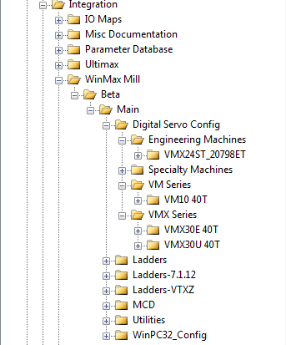

Figure 4 – TFS Integration Digital Servo Config Tree Structure

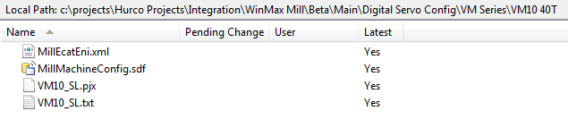

Figure 5 – TFS Integration Digital Servo Machine Files

Once the new TFS Digital Servo Config structure and files are in place, a mechanism is still needed to copy the configuration files from their source locations to their destination locations. With the digital drive system, the new database and ENI files will be located in the root of the existing R:\Hurco\Winmax\ConfigFiles\RT folder. The destination location for the WinPC32 projects files will remain unchanged in the existing subfolder under the C:\Program Files\Hurco\WinPC32 folder.

There have been numerous discussions about the Machine Selector replacement for the digital drive system. Several enhancements have been proposed but due to lack of time and resources, no formal design has been developed. Until this replacement can be designed, an interim approach will be to modify the existing Machine Selector app to support the digital drive machines.

A new registry key will be used with the Machine Selector to control the available main menu selections, based on whether the system is an analog drive or digital drive system. For backwards compatibility, the default value of the new registry key will indicate an analog drive system. Analog drive systems will display the Machine Selector main menu as shown in Figure 3 and digital drive systems will display the Machine Selector main menu as shown in Figure 6. The MachineConfig.xml file will be extended to support the digital drive machines and the Machine Selector app will have minor changes made to support the differences between the analog drive and digital drive configuration files.

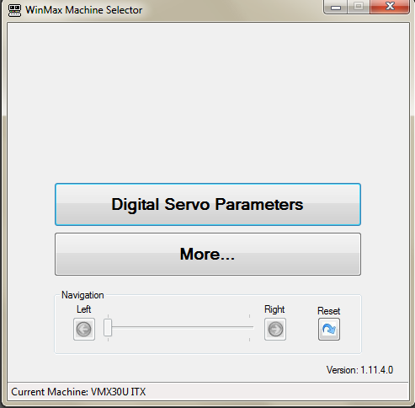

Figure 6 – Machine Selector Main Screen (Digital Drive System)